

Ngā Pae o te Māramatanga Whakaaweawe Grant Round 2024

GRANT APPLICATION

CLOSING DATE 02 September 2024, 5.00PM

Ngā Pae o te Māramatanga (NPM) is inviting applications for our 2024 Whakaaweawe Impact and Transformation Grants.

Purpose
NPM Whakaaweawe Impact and Transformation Grants support Māori researchers employed at a NPM partner entity to achieve research outcomes and knowledge sharing pathways that harness connectedness and promote research uptake and impact.

Supported activities
The types of activities supported by this grant might include individual or collective outputs including artistic works, performances, and creative designs, policies, or processes. They might also include activities that lead to scholarly books, journal articles, and other nationally and internationally published outputs and presentations that offer new, recovered, or reinterpreted knowledge.
Examples of what the grant might be used for including: creating digital assets including film, photography, infographics, illustrations; creating interactive experiences such as board games and exhibitions; creating performative or artistic articulations of research findings such as film and compositions; publication and final editing costs; Open Access expenses; hosting or attending an in-person event, hui, wānanga or conference.

Successful applicants in the past have used this grant to support research outputs that have included books, journal articles, free online resources, app development, performance of haka, translation of existing work into te reo Māori for publication, and to attend and present research at conferences.

Eligibility
The lead applicant must be a Māori researcher employed at an NPM partner entity.

Duration
Applicants must be prepared to spend their fully allocated budget by 30th June 2025 and complete all project objectives.

Value
We expect to support a mix of 10-15 projects, valued up to $3,000 and larger projects up to $7,000, from a total funding pool of $50,000 NZD.

For applicants seeking support to present an accepted, peer-reviewed paper at an academic conference, the maximum that may be applied for is $2,500 and may be used to cover registration at online or in-person conferences, travel and accommodation.

Closing Date
02nd September 2024, 5.00pm

How to apply
Applications must be submitted through the NPM online application portal. Applications should include:
- Complete 2024 NPM Whakaaweawe – Impact and Transformation Grant Application
- Lead Researcher’s CV in New Zealand Standard Curriculum Vitae Template
- Complete NPM Budget Template
- Supporting quotes and evidence

INSTRUCTIONS
- Prepare the application document first. This should be done off-line.
- Prepare all associated files for uploading including the excel budget spreadsheet.
- DELETE all informational and instructional pages (p1-2)
- DELETE all text-coloured grey.
- Ensure all your responses are in font 11pt or above and coloured black. Ensure all sections of the application are completed.
- Once you are ready, have the application document open and begin the online form.
- Copy and paste the required information from your application into the online form, and complete any additional information requested in this online form.
- Make sure the filenames you use accurately describe the information in the file and are uploaded under the correct upload headings.
- Attach and upload ALL your files.
- Complete a final check on your online application.
- Finally, press the SUBMIT button and wait for the confirmation screen. You must do this for your application to be sent.

More information regarding applications is available through the online application portal:
[https://auckland.au1.qualtrics.com/jfe/form/SV_eRlHrvUCJfQrZb0]

Contact
For application queries please email: research@maramatanga.ac.nz.

Matakitenga Framework
You can view the framework in Appendix 1 at the end of this document or online here or download a copy.

NGĀ PAE O TE MĀRAMATANGA 2024 WHAKAAWEAWE GRANT APPLICATION

SECTION 1 - OVERVIEW

Lead Researcher Details
Lead Researcher Name | Title, First, Last name
Iwi affiliation/s | Separate iwi with a comma
NPM Partner Entity | (Where Lead Researcher is employed)
Position at Partner Entity | (e.g., Professor, Research fellow, lecturer)
Email | (work email)

Work/Mobile number

Project title
Provide a descriptive title not more than two lines long

Lay summary
Provide a lay summary (max 250 words) of the project that may be shared publicly. Include a brief background to the project, the research question(s), project aims and objectives, and why the research is important. Include audience and reach of the proposed impact and transformation activity and evidence that the activity will facilitate connectedness, reciprocity and uptake with research stakeholders and communities.

Alignment
Which Pae or Rautaki is this research most aligned to? Check one only.
Refer to the NPM Matakitenga Research Framework (Appendix 1)

Ahurei |  | Ora |  | Tawhiti |  | Auaha
Kounga |  | Whakaaweawe

Which Pātai is this research most aligned to? Check one only.

Te Ao Māori |  | Whānau |  | Mauri |  | Puāwai

SECTION 2 – PROJECT OUTCOMES AND IMPACT

What do you expect to achieve with this project, and what will its impact be?
Provide a brief description of the expected achievements and impact of this project.

What are your project objectives and expected completion dates?
An objective is a research task to be achieved (e.g., design wānanga, obtain ethical review, hold community hui, deliver stakeholder policy seminar, submit manuscript). You should list a minimum of three objectives.
 | PROJECT objectives | Expected completion date
1 | DELETE (complete and obtain ethical review) | DD/MM/YY
2 | DELETE (recruit and complete 20 interviews) | DD/MM/YY
3
4
5
6 | Complete all NPM reporting requirements | 30th June 2025
Expand as required

List 3-5 Matakitenga outcomes your research project relates to directly.
Please refer to the outcome statements in the NPM Matakitenga research framework. The Matakitenga indicator are the 4 characters that precede the outcome statement.
 | Matakitenga indicator | Matakitenga outcome statement
1 | (e.g., AAH1) | DELETE (e.g., Research to protect, regenerate and future proof Te Ao Māori)
2
3
4
5
Expand as required

How will your project contribute to the Matakitenga outcomes you have listed above?
 | Matakitenga indicator | Research Contribution
1 | (e.g., AAH1) | DELETE (e.g., Our research will emerge novel Te Ao Māori inspired conservation strategies for urban application)
2 | (e.g., PAU4) | DELETE (e.g., Our bi-weekly project newsletter will create discussion and nurture the ethical use of digital marae platform)
3 | (e.g., MTA3) | DELETE (e.g., Our policy focused journal article and high impact webinar will influence economic awareness and policy for mana and mauri centred decision-making).
Expand as required

SECTION 3 - PROJECT PLAN

Tell us what your proposed project is about and why it matters.
Include reference to any significant previous research in the field, and the contribution expected to be made by the proposed research. What evidence can you provide that your project will facilitate connectedness, reciprocity and an uptake with research stakeholders and communities.
(Half page max)

Expand as required

Where will the research take place? (check all that apply)
Include reference to any significant previous research in the field, and the contribution.
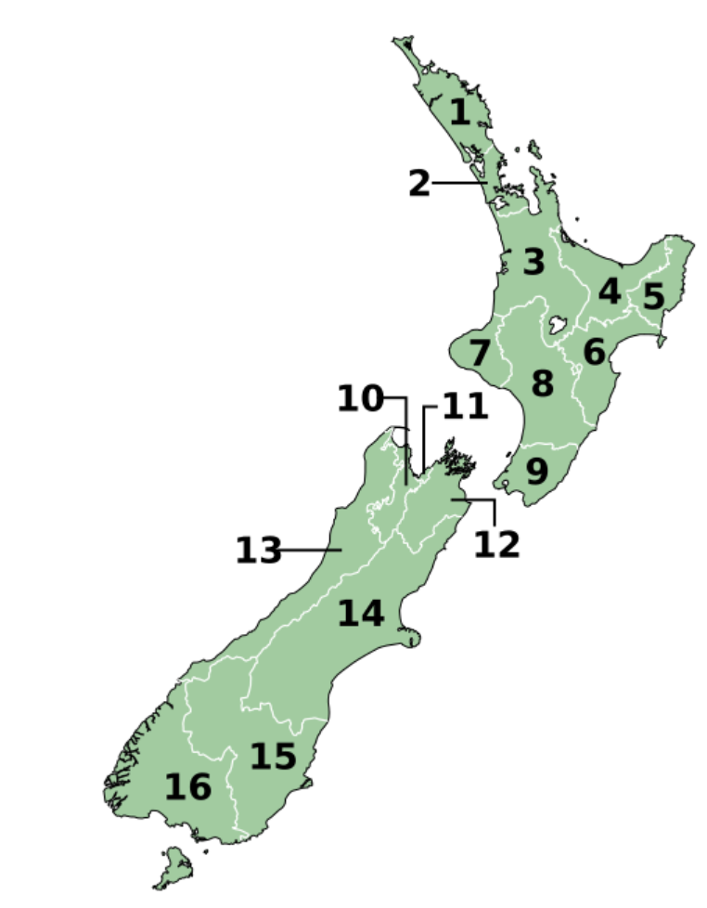

☐ 1 Northland - Te Tai Tokerau
☐ 2 Auckland - Tāmaki-makau-rau
☐ 3 Waikato
☐ 4 Bay of Plenty - Te Moana-a-Toi
☐ 5 Gisborne - Te Tairāwhiti
☐ 6 Hawke's Bay - Te Matau-a-Māui
☐ 7 Taranaki
☐ 8 Manawatū-Whanganui
☐ 9 Wellington - Te Whanga-nui-a-Tara
☐ 10 Tasman - Te Tai-o-Aorere
☐ 11 Nelson - Whakatū
☐ 12 Marlborough - Te Tauihu-o-te-waka
☐ 13 West Coast - Te Tai Poutini
☐ 14 Canterbury - Waitaha
☐ 15 Otago - Ōtākou
☐ 16 Southland – Murihiku

Community of Interest
A “Community of Interest” may be an iwi or hapū group, a group of landowners or beneficiaries, a community that shares a commonality (e.g., students, athletes), or group that seeks to advance a goal (e.g., ending racism, better health services).

If you are working with a Community of Interest, please name and briefly describe the nature of the engagement.
Community name
Nature of engagement
Community name
Nature of engagement
Expand as required

Who is the intended audience for your Whakaaweawe project?
(Half page max)

Expand as required

If relevant, indicate how you will meet the data sovereignty requirements of Māori community partners and/or Māori participants.
(Half page max)

TE REO MĀORI EXPERTISE
A suitably qualified Te Reo Māori expert must undertake a Te Reo Māori edit for all Te Reo Māori content included in the final publication. If this applies to this project, name the person who will undertake this edit and briefly outline their qualifications - formal and/or non-formal.
Name: | Qualifications:
FOR PUBLICATIONS PROJECTS
COPYRIGHT MATERIAL
Will you be using content (e.g., photos, graphics, audio etc) for which permission from the copyright holder is required? Note below the content type and permission status or arrangements to gain permission.
Content | Permission status or arrangement

SECTION 4 - ETHICS

DID YOUR RESEARCH IN THIS PROJECT REQUIRE Ethical approval
Is ethical approval required for the proposed project? | Yes |  |  | No

If ‘YES’, please complete the following sections:
What type of ethical approval is required?  (Please select what applies) | Human Ethics
 | Biological Safety Ethics
 | Animal Ethics
 | Other-please specify:
What is the current status of the required ethical approval?  (Please select what applies) | Ethical Approval application will be prepared and submitted as part of the proposed research project.
 | Ethical Approval application has been submitted, awaiting approval.
 | Ethical Approval has been granted (please provide approval letter).
 | Other- please provide further detail in the comment.
 | Ethical Approval application will be prepared and submitted as part of the proposed research project.

If ‘NO’, please detail why ethical approval is not required

SECTION 5 – BUDGET

SECTION FIVE – BUDGET
2024 WHAKAAWEAWE SUPPORT GRANT BUDGET
Proposed Budget (Provide details and supporting documentation, including quotes, for budget items listed below.)
Item | Item description | Amount
1
2
3
4
5
6
 | Sub total
 | G.S.T.
 | Total
Expand as required

CO-FUNDING
Provide details of any funding received (or to be received) from elsewhere to co-fund activities or items detailed in this proposal.
Co-funder | Purpose/Items | $ Amount

SECTION FIVE – SIGNATURE

THIS PAGE MUST BE SIGNED

NPM Lead Researcher name | Signature:
NPM Lead Researcher name | Date:

DOCUMENTS TO BE UPLOADED
WHAKAAWEAWE SUPPORT GRANT 2024 APPLICATION FORM
Upload the completed and sign version of this application form

APPLICANT’S CURRICULUM VITAE
Upload your CV in RSNZ format (5 pages max)

NPM BUDGET DOCUMENT
Upload NPM Budget document

QUOTES
Upload supporting documents that confirm the accuracy of your budget (i.e., quotes especially for significant expenses and sub-contractors).

NPM Matakitenga Research Framework (Appendix 1)

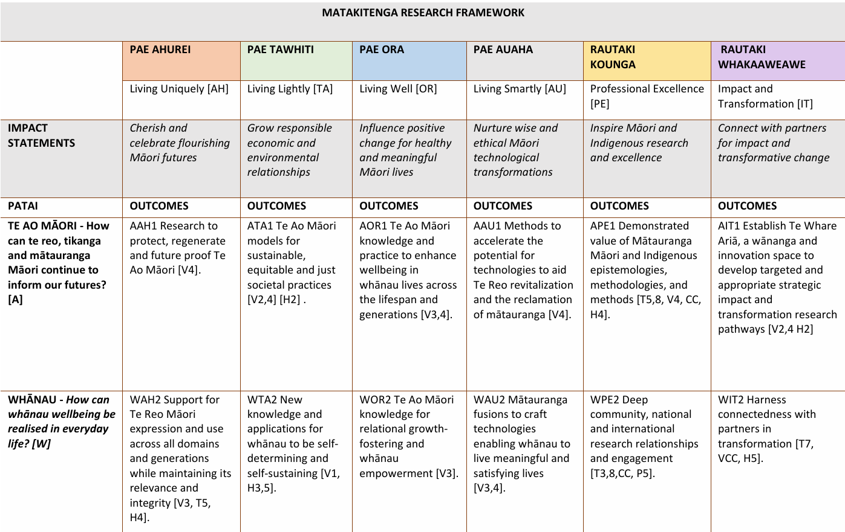
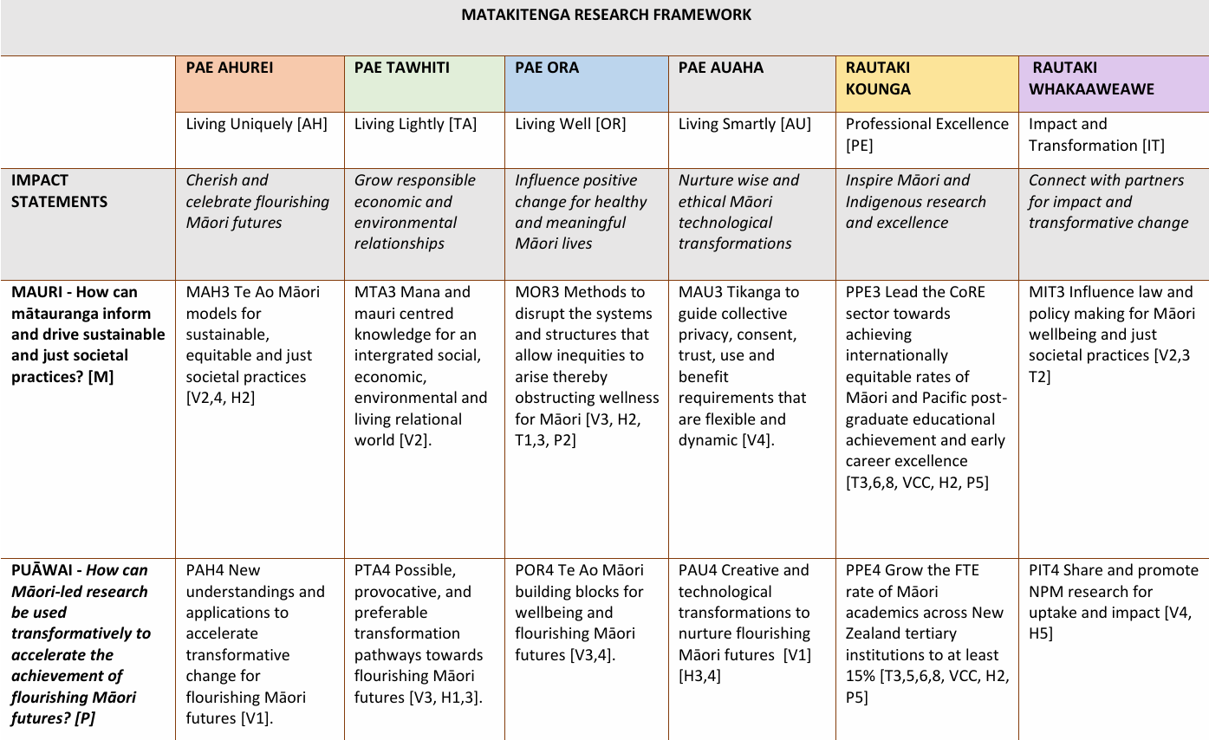

Matakitenga Framework
You can view the framework online here or download a copy.

